NAME: Ishwaryaa N
ROLL NO: 240701196
Experiment:
DESIGN A UI WHERE USERS RECALL VISUAL ELEMENTS (E.G.ICONS OR TEXT CHUNKS).EVALUATE THE EFFECT OF CHUNKING ON USER MEMORY
Problem Statement:
Design an interactive mobile user interface that enables users to recall visual elements such as shapes and images. Evaluate how the chunking technique improves memory retention, recall accuracy, and user performance.

FRAME 1: HOME / START PAGE
Analysis of the Start Screen
This screen acts as the entry point of the memory game titled “Mind Mash”. It prepares the user to begin the activity in a simple and engaging manner.
1. Purpose of the Screen
- Introduces the game
- Creates first impression
- Allows users to start the task easily
2. Key UI Elements
- Bold title “MIND MASH” → clearly shows the game name
- Brain mascot illustration → represents thinking and memory
- Minimal design → avoids distraction
- Large START button → easy navigation
3. Visual Design
- Blue gradient background gives a calm and focused feel
- Central alignment highlights important elements
- Friendly cartoon improves engagement
4. UX Benefits
- Simple layout reduces cognitive load
- One clear action (Start) avoids confusion
- Attractive visuals motivate users to continue
✅ Outcome: User clearly understands how to begin the game.
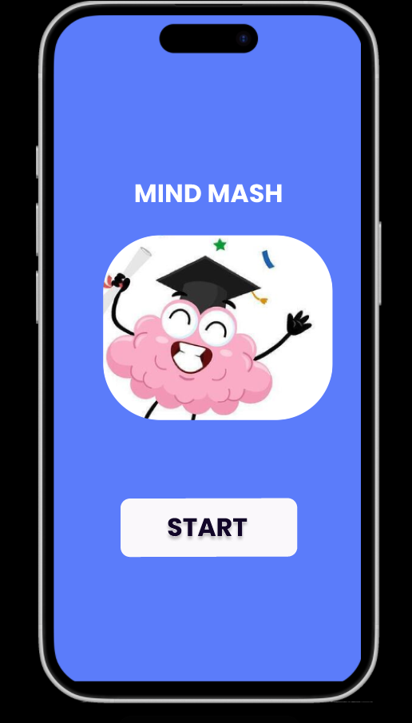

FRAME 2: INSTRUCTION PAGE:
Chunking Analysis of the Instruction Page
This screen provides step-by-step guidance about how the game works.
1. Purpose of the Screen
- Explains game rules
- Prepares users mentally
- Reduces errors during gameplay
2. Chunking of Instructions
Instructions are divided into three clear steps:
- Remember
- Solve
- Score
Breaking instructions into small parts makes them easier to process and remember.
3. Key UI Components
- Bold header “INSTRUCTIONS”
- Numbered steps for clarity
- Time information “30 seconds”
- BEGIN button for next action
4. Design Features
- Proper spacing
- Card-style layout
- Clear typography
5. Cognitive Benefits
- Reduces overload
- Improves understanding
- Guides user sequentially
✅ Outcome: Users know exactly what to do before starting the memory task.
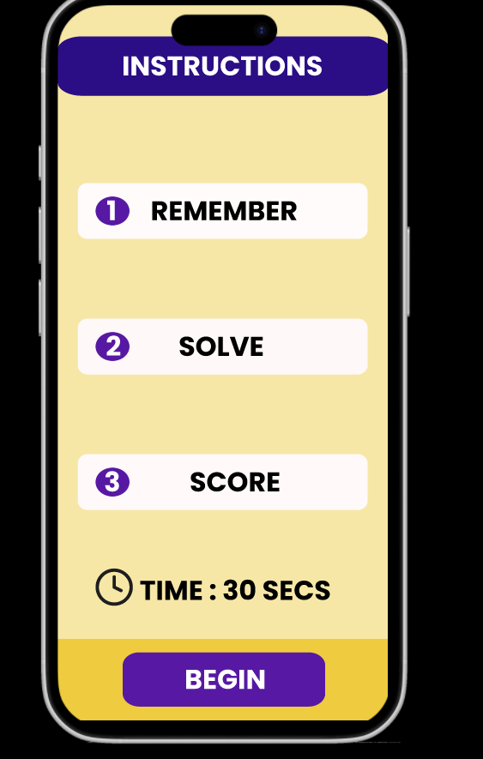

FRAME 3: CHUNKING / MEMORY PHASE:
Analysis of the Memory Observation Screen
This screen represents the encoding stage, where users observe shapes and memorize them.
1. Purpose of the Screen
- Display shapes for memorization
- Encourage users to group similar items
- Apply chunking strategy
2. Key UI Components
- Text: “Remember these shapes”
- Timer (5 seconds) → limits observation time
- Grid of shapes (circle, square, triangle, etc.)
- NEXT button
3. Chunking Principle Applied
Instead of remembering each shape separately, users mentally group them:
- All circles together
- All squares together
- All triangles together
This reduces memory load.
4. Visual Design
- Bright red background increases alertness
- Clear icons for easy recognition
- Structured layout supports grouping
5. Cognitive & UX Benefits
- Improves short-term memory
- Enhances focus
- Faster recognition
✅ Outcome: Users encode visual information efficiently using chunking.
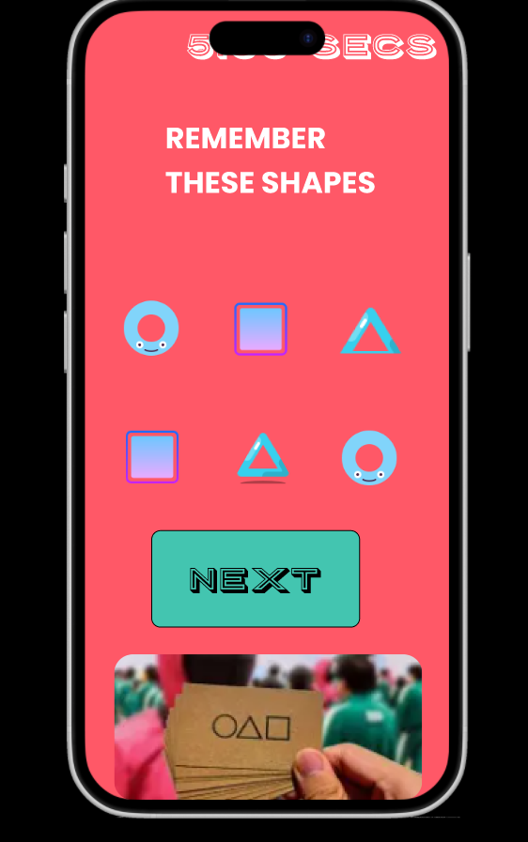

FRAME 4: RECALL / SELECTION PHASE:
Analysis of the Recall Task Screen
This screen tests how well users remember the previously shown items.
1. Purpose of the Screen
- Evaluate memory retention
- Test recall accuracy
- Encourage problem solving
2. Key UI Components
- Task statement “Solve this”
- Visual puzzle using images
- Interactive choices
- GO button to submit
3. Working
- User recalls previous shapes
- Solves the puzzle
- Submits answer
4. Cognitive Benefits
- Strengthens retrieval memory
- Improves logical thinking
- Encourages concentration
5. UX Benefits
- Gamified interaction
- Fun cartoon theme
- Keeps users engaged
✅ Outcome: System measures how accurately users recall chunked information.
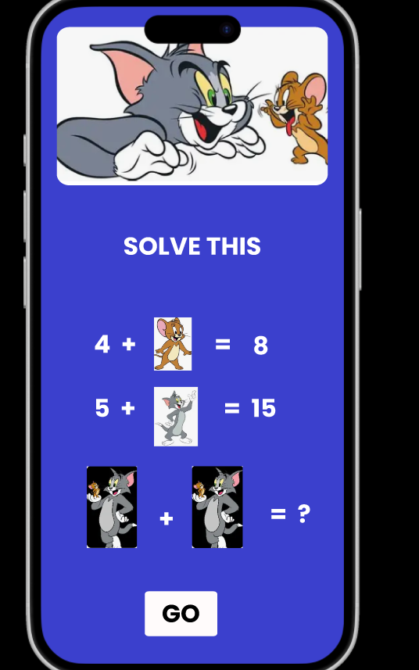

FRAME 5: FEEDBACK PAGE:
Analysis of the Immediate Feedback Screen
This screen provides confirmation about the user’s answer.
1. Purpose
- Show whether answer is correct
- Provide instant feedback
2. Key UI Elements
- Message “You’re Correct”
- Display of correct result
- CHECK button
3. UX Benefits
- Instant reinforcement improves learning
- Builds confidence
- Encourages continued play
✅ Outcome: Users understand their performance immediately.
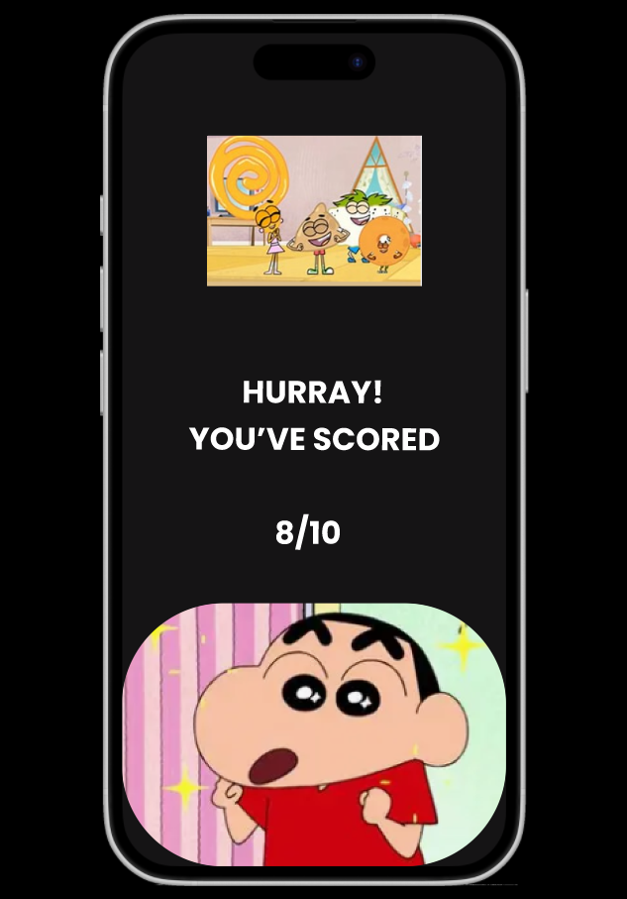

FRAME 6: RESULT / SCORE PAGE
Analysis of the Score & Final Feedback Screen
This is the final stage where overall performance is displayed.
1. Purpose
- Show final score
- Evaluate performance
- End the task positively
2. Key UI Components
- Message “Hurray! You’ve Scored”
- Score display (Example: 8/10)
- Fun cartoon character
3. Visual Design
- Dark background highlights score
- Celebratory graphics create satisfaction
4. Cognitive & UX Benefits
- Motivates improvement
- Encourages replay
- Makes learning enjoyable
✅ Outcome: Users evaluate their memory ability and feel rewarded.

Working of the System
- User starts the game
- Reads instructions
- Observes shapes (chunking phase)
- Memorizes using grouping
- Solves recall task
- Receives feedback
- Views final score

Result
- Users who grouped shapes performed better
- Chunking reduced memory effort
- Time-bound tasks increased focus
- Gamified UI improved engagement

Conclusion
The designed Mind Mash Memory Game successfully demonstrates the effectiveness of the chunking technique in improving short-term memory.
By organizing information visually, limiting time, and providing interactive feedback, the interface:
- Reduces cognitive load
- Enhances recall accuracy
- Improves learning experience
- Makes the task enjoyable
Thus, chunking plays a vital role in designing efficient and user-friendly memory-based interfaces.
PROTOTYPE LINK:
https://www.figma.com/proto/fw906LF50PedQLA78GDZ0N/Memory-game?page-id=0%3A1&node-id=1-3&p=f&viewport=-267%2C215%2C0.44&t=02IzdM05cvwCpjSp-1&scaling=scale-down&content-scaling=fixed&starting-point-node-id=1%3A8

